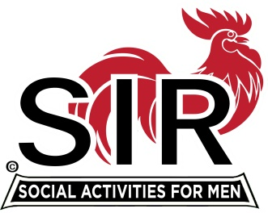
Las Trampas Branch 116
Meeting Agenda
August 17., 2020, 11:45 AM
The Mission of SIR is to enhance the lives of our members through fun activities, events and luncheons – while making friends for life

11:45 Social Time

12:00 BIG Sir: Welcome

12:05 Little SIR: Introduction of Speaker Glenn King followed by Q & A

12:40 Little SIR: Speaker “Thanks.’

12:45 Voting for slate of officers 2021 (Neil to facilitate)

1:00 Activities: Fred Wachowicz
Bernie Wroblewski

1:15 Little SIR: Birthday Boys

1:20 Big Sir: Close Meeting

